Segments
Cylindrical segment
input
D = diameter (in)
h_{i}= initial height (ft)
h_{f} = final height (ft)
H = total height (ft)
t = thickness (in)
output
A_{p} = projected area (ft²) = 12(h)(d)
Centroid of projected area = h_{i} + h/2
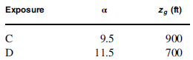
Weight of the pedestal = $\frac{π}{4}$(D² – (D-2*t/12)²) H r_{s}/1000 (kips)
k_{zi} = 2.01(h_{i} /Z_{g})^{2/a}
k_{zf}= 2.01(h_{f} /Z_{g})^{2/a}
q_{zi} = 0.00256 K_{zi} K_{zt} K_{d} I V² , other parameters shall be obtained from wind load
q_{zf} = 0.00256 K_{zf} K_{zt} K_{d} I V²
F = $\frac{q_{zi}+q_{zt}}{2}$ A_{P}
L= lever arm between the base and the location of the force F= h_{i} + $\frac{q_{zi}h^{2}/2+0.5(q_{zf}-q_{zi}){2h}^{2}/3}{q_{zi}h+0.5\left(q_{zf}-q_{zi}\right)h}$
M _{base} = L * F

Conical segment
input
D_{i} = initial diameter (ft)
D_{f} = Final diameter (ft)
h_{i}= initial height (ft)
h_{f} = final height (ft)
H = total height (ft)
t = thickness (in)
output
A_{p} = projected area (ft²) = (h)(d)
Centroid of projected area = h_{i} + h/2
S₁ = $\frac{π}{4}$D_{i}²
S₂ = $\frac{π}{4}$D_{f}²
S₃ = $\frac{π}{4}($D_{i}-t/12)²
S₄ = $\frac{π}{4}($D_{f}-t/12) ²

W = (H/3 *( S₁ + S₂ - S₃ - S₄ +$\sqrt{S_{1}S_{2}}$ -$\sqrt{S_{3}S_{4}}$)) r_{s}/1000 (kips)

k_{zi} = 2.01(h_{i} /Z_{g})^{2/a}
k_{zf}= 2.01(h_{f} /Z_{g})^{2/a}
q_{zi} = 0.00256 K_{zi} K_{zt} K_{d} I V² , other parameters shall be obtained from wind load
q_{zf} = 0.00256 K_{zf} K_{zt} K_{d} I V²
F = $\frac{q_{zi}+q_{zf}}{2}$ A_{P}
L= lever arm between the base and the location of the force F= h_{i} + $\frac{q_{zi}h^{2}/2+0.5(q_{zf}-q_{zi}){2h}^{2}/3}{q_{zi}h+0.5\left(q_{zf}-q_{zi}\right)h}$
M _{base} = L * F

Snow Load
- Ground snow load P_{g} shall be based on ASCE 7
- Flat roof snow load P_{f} = 0.7 C_{e} C_{t} I_{s} P_{g}
- C_{e} = 0.9 for wind Exposure C
- = 0.8 for wind Exposure D
- C_{t} = 1.2 for unheated and open-air structures
- I_{s} = 1.0 for Risk Category II
- = 1.1 for Risk Category III
- = 1.2 for Risk Category IV
- Slopped roof snow load
- Wherever the angle between the tangent of the tank and the horizontal axis is greater than 70º the snow load shall be zero. (They assume it on half the diameter.)
- C_{s} = (70- a)/55
- P_{s} = C_{s} P_{f}
- The minimum snow load is 0.96 N/m² (20 psf)

balconies, platforms, ladders, stairs
- 1,000 lb (454 kg) to any 10 ft² (0.93 m²) area on balcony floors.
- 1,000 lb (454 kg) to each platform.
- 500 lb (227 kg) to any 10 ft² (0.93 m²) area on tank roofs.
- These loads need not be combined with design snow load requirements.
- These loads need not be applied simultaneously.

Content weight
- W_{content} = V r_{w}

Constants
- r_{w} = 62.4 pcf
- r_{s} = 490 pcf
- r_{c} = 144 pcf

Lateral Loads

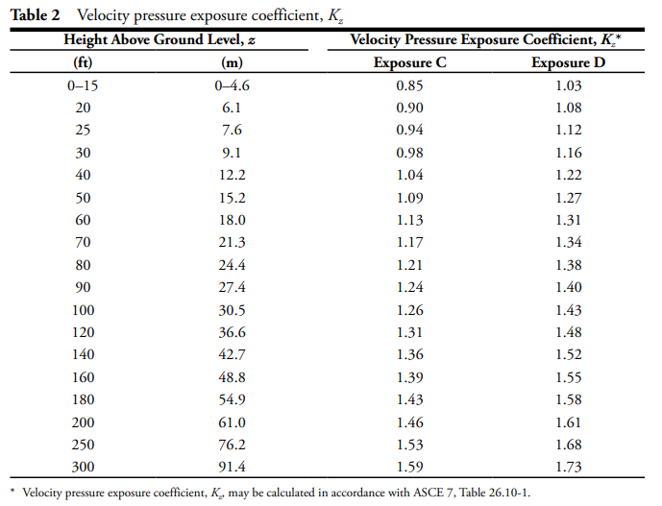
Wind load
- q_{z} = Y l_{w} 0.000256 K_{z} K_{zt} K_{d} I V²
- l_{w} = strength-level to service-level factor for wind load
- K_{d} = directionality factor 1.0
- Y=0.6
- V = basic wind speed

- K_{zt} = Topography factor normally (1.0)
- K_{z} = Velocity pressure factor. 2.01(Z/Z_{g})^{2/a}
- I_{w} = 1.15 (We are not going to use this I)
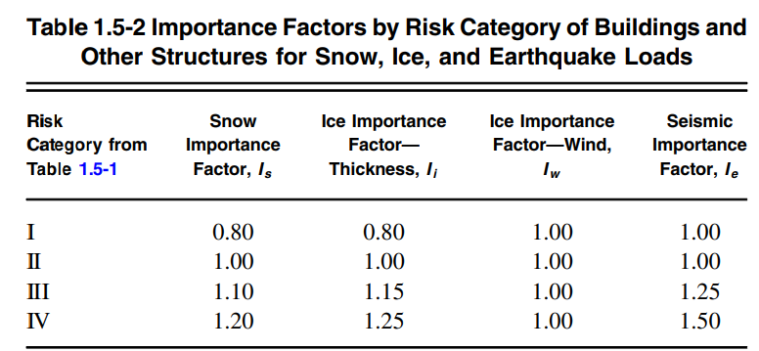
- P_{w} = q_{z} G C_{f} ≥ 30 C_{f}
- F = P_{w} A_{f}
- A_{f} = p a b

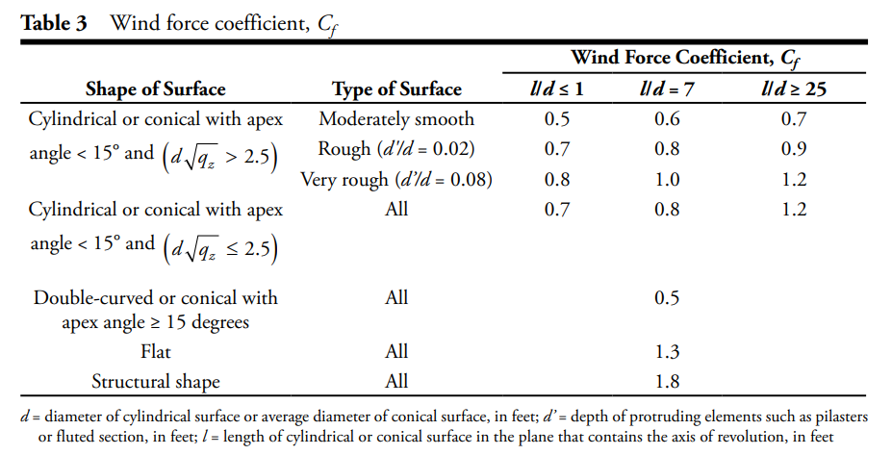
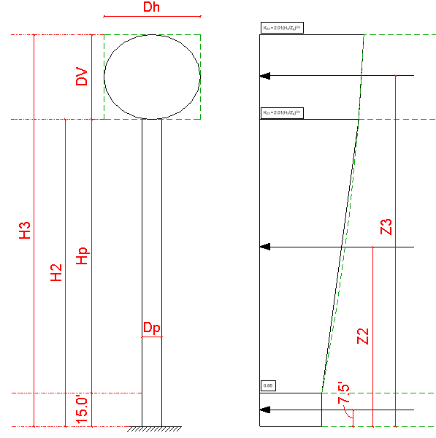
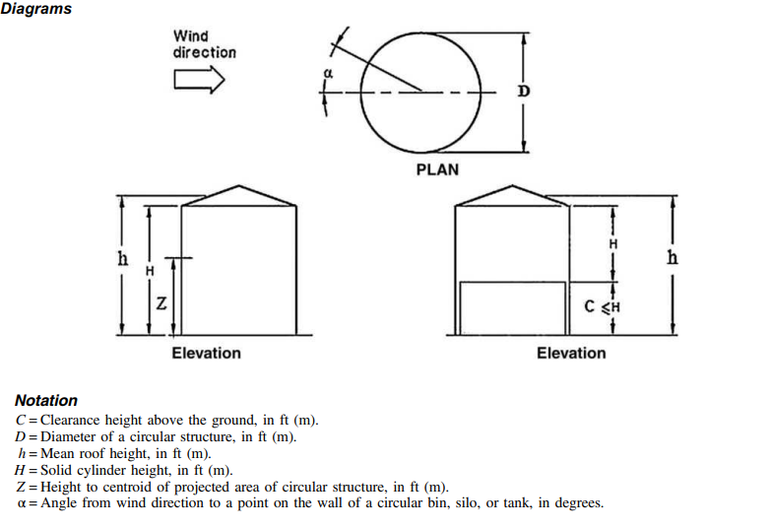

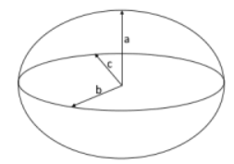
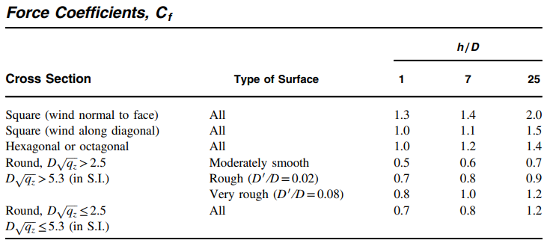

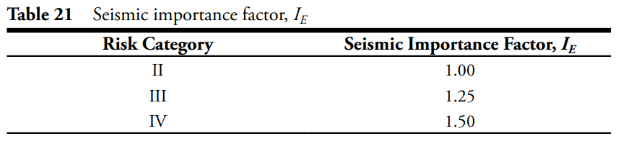
Seismic load
- S_{DS} = 2/3 S_{MS}
- S_{D1} = 2/3 S_{M1}
- S_{MS} = F_{a} S_{s}
- S_{M1} = F_{v} S₁
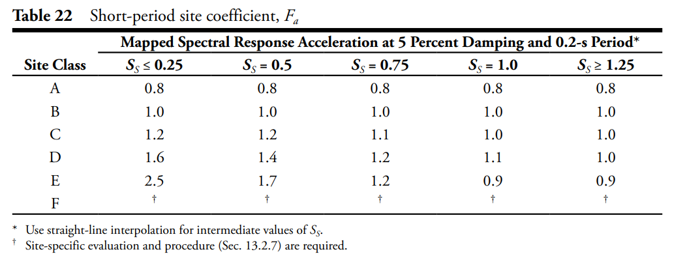
- S₁ & S₁ are the mapped spectral acceleration parameters

Design response spectrum for impulsive component
T_{i} ≤ T_{s} S_{ai} = S_{DS}
T_{s} ≤ T_{i} ≤ T_{L} S_{ai} = S_{D1} / T_{i} ≥ S_{DS}
T_{i} ≥ T_{L} S_{ai} = S_{D1} T_{L} / T_{i}²

T_{s} = S_{D1}/S_{Ds}

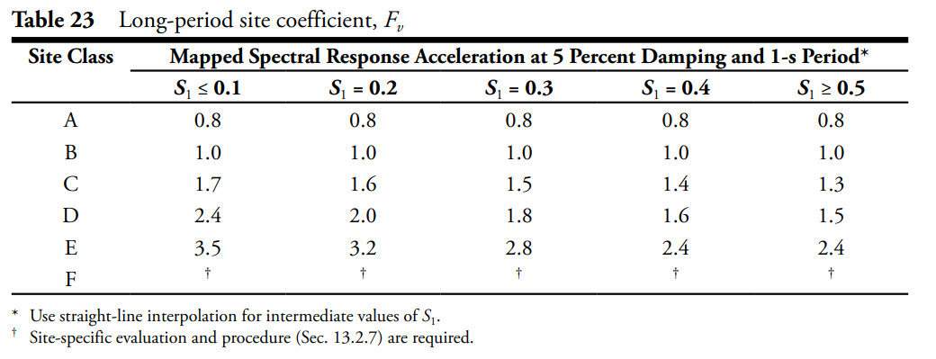
- A_{i} = $\frac{λ_{E}S_{ai}I_{E}}{R_{i}}$ ≥ $\frac{0.36 S_{1}I_{E}}{R_{i}}$
- $λ_{E}$ is the strength-level to service-level factor for seismic = 0.70
- V = A_{i} W
- W is the weight of the structure plus the content.
- Force V applies at the tank's center of mass.

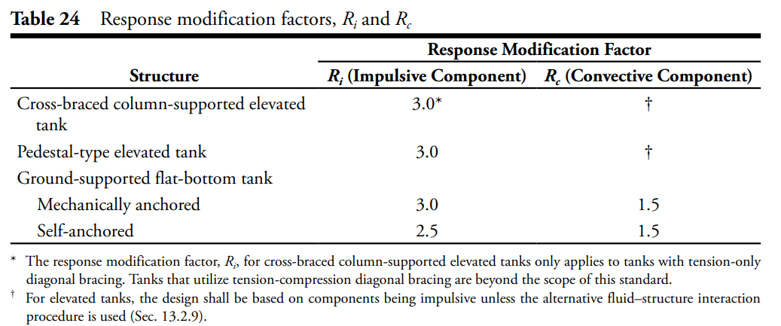

Critical questions
- How do you calculate the weight of water and structure? (This question is just to be on the same page.)
- How to accurately find C_{f}?
- How to calculate the fundamental period of the structure? Codes and standards recommend using the short period for the impulsive component. However, in the calculation books, they were putting a value for the period without telling how.

